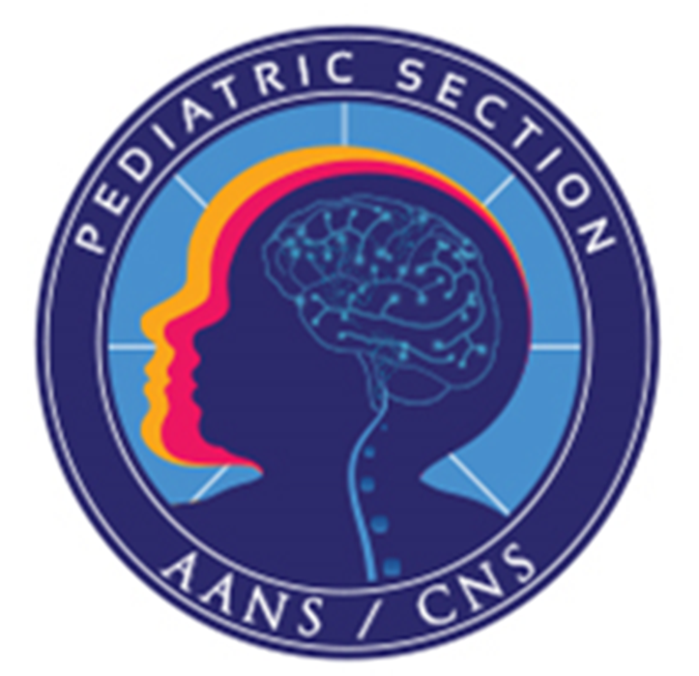

Questionnaire:

To have your program listed for potential traveling fellows, please specify which fellowship(s) you are willing to sponsor:

International Traveling Fellowship in Pediatric Neurosurgery (3 months) Resident Traveling Fellowship in Pediatric Neurosurgery (1 month)

SPONSORING INSTITUTION

Name of Institution/Program: Name of Program Director: Address:
Telephone: Fax:
Email: Website URL:

Please attach a 150-250 word description of your program, including the number of faculty/attendings, number and type of trainees, clinical volume, specialty practices, parent institution, geographic location, and any other details you feel may help a potential candidate gauge their suitability to your program. If you have a Web page(s) to your Pediatric Neurosurgery Service, please provide the URL in the space provided above, and we will link to your site on the AANS/CNS Joint Section for Pediatric Neurosurgery website for potential applicants. Sponsors must be willing to provide a letter of recommendation from the program director and a letter of acceptance from the institution confirming the description of the fellow’s anticipated activities during the period of the award.

Please email the completed form to the Training Subcommittee Chair, Ed Ahn at ahn.edward@mayo.edu.

